Practical - 7
Practical Title: PHP Form Processing with Server-Side Validation and CSV/JSON File Storage Problem Definition: Display event lists, student profiles, notices, or FAQs from external JSON files using Fetch API. Implement dynamic rendering, search, filter, sorting, and pagination.

Theory :

1. Is the form submitted using POST?
Ans:Yes, the form uses the POST method to submit data securely.

2. Are inputs validated and sanitized server side?
Ans: Yes, inputs are validated and sanitized on the server side.

3. Is file writing handled safely
Ans: Yes, file writing is performed safely with proper handling.

4. Are success and error responses displayed clearly?
Ans:Yes, clear success and error messages are displayed to the user.

- Evidence of Work (Screenshots):

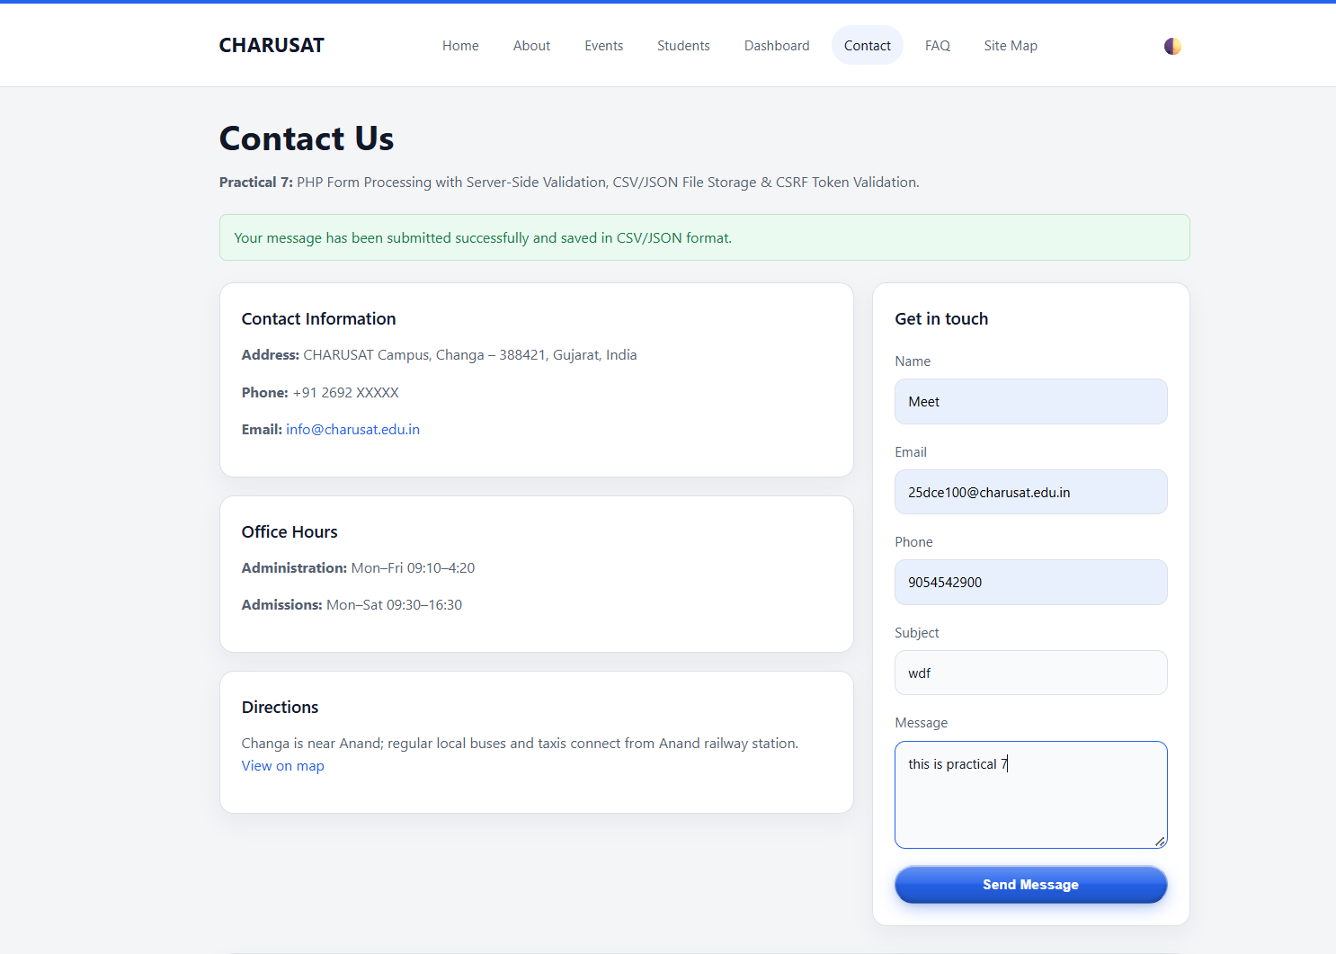

LIVE RECORD TABLE:
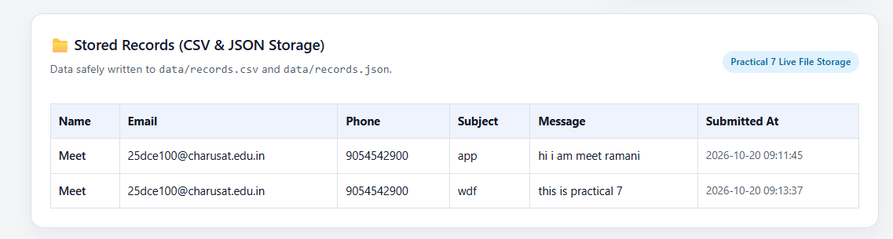

CSV FILE:
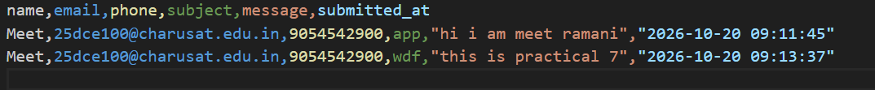

JSON FILE:
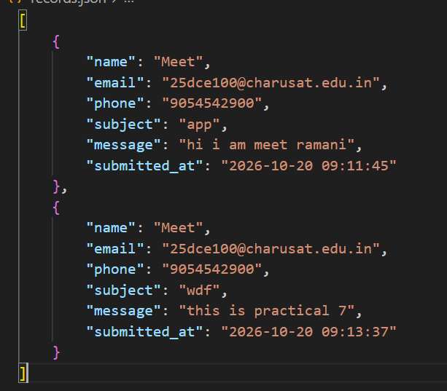

Repository Link :-
https://github.com/meet-3834/Student-Hub/tree/main/FINAL%20Submission

- Learning Outcomes:
I am able to implement server-side form processing with safe file-based
storage.

Faculty Remarks: (Keep this blank for faculty)

